ข้อ 1

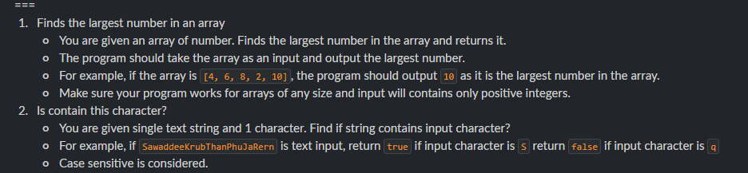

ข้อ 2

ข้อ 3

ข้อ 4

ข้อ 5

ข้อ 6

ข้อ 7

ข้อ 8

ข้อ 9

ข้อ 10

ข้อ 11

